New Medical Client
Welcome to Premier Aesthetics! We are so happy to have you. Due to recent guidelines we are conducting our consults virtually. Please send us pictures of yourself in these 3 poses and fill out the medical history below.

Patient Name: _____________________________________DOB:________________________
Date: _____________ Email: _________________________ Phone Number: _______________
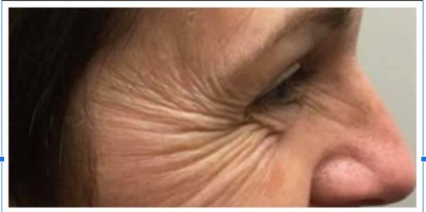
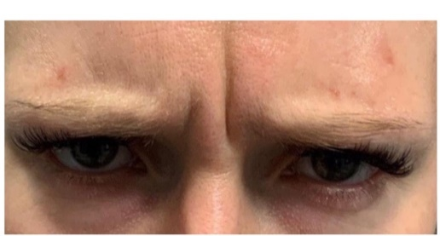
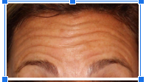
Example Pictures
Medical History Reviewed
- Allergies _____________________
- Change of medical history since last visit?________________
- Pregnant, Breast Feeding, Postpartum? _______________
- No history of neuromuscular diseases? (Guillain Barre, Lambert Eaton Syndrome, Myasthenia Gravis, Multiple Sclerosis, Parkinson’s)
- If applicable, no issues with previous treatment? __________________________
- Autoimmune Diseases? ____________
- Recent use of ASA, Vitamin E, NSAIDS, Gingko Biloba, Fish oil, Anticoagulants Last date of use: ___________________

Chief Complaint/Results you would like to see: ___________________________________________

Check the box for the following services you are interested in:

Botox/Dysport/Xeomin Dermal Filler PDO Threads

Laser Hair Removal/ IPL Opus Salt Facial

IF ANY OF THE FOLLOWING QUESTIONS APPLY TO YOU PLEASE NOTIFY US IN THIS CONSENT.

Once we receive the following information, we will send them to our doctor for his approval. We will then call you to schedule an appointment.

